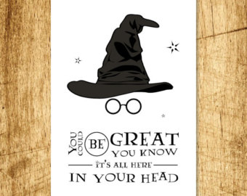

**SECOND roll of the dice**

1=Imagery

2=simile or metaphor

3=pun

4=idiom

5=hyperbole

6=personification

**THIRD roll of the dice**

1=Use a dash

2=Use a Rhetorical Fallacy

3=Use Sentence Construction with a

Purpose

**FIRST roll of the dice**

1=Compound sentence with semicolon or

Semicolon, conjunctive adverb, comma

2=FANBOYS

3=Appositive Phrase or Adjective

Clause

4=Adverb Clause or Infinitive Phrase

5=Participle Phrase or Gerund Phrase

6=Prepositional Phrase or Noun Clause

Greatness Awaits