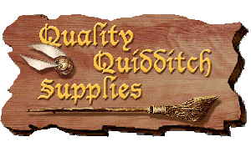

Quidditch Bad Writing Habits

**Roll the dice to Quidditch the writing skills that need revising.**

1=Find 3 sentences to add phrases or clauses to extend information.

2=Find 3 sentences to combine into compound sentences.

3=Find a place in supporting details or examples to add figurative language.

4=Find a place in supporting details or examples to add imagery.

5=Find 5 places that need diction improvement.

6=Find 2 places to take a RISK using Sentence Variation Models or

Sentence Construction with a Purpose.